**DN 4.0 JAVA FSE SOLUTIONS – WEEK 4**

**SKILL: Spring REST using Spring Boot 3**

**HandsOn 1:** Create a Spring Web Project using Maven

**Code:**

**src/main/java/com/cognizant/springlearn/SpringLearnApplication.java -**

package com.cognizant.springlearn;  
import org.springframework.boot.SpringApplication;  
import org.springframework.boot.autoconfigure.SpringBootApplication;  
@SpringBootApplication  
public class SpringLearnApplication {  
 public static void main(String[] args) {  
 SpringApplication.*run*(SpringLearnApplication.class, args);  
 System.*out*.println("Application started successfully.");  
 }  
}

**pom.xml -**

<?xml version="1.0" encoding="UTF-8"?>  
<project xmlns="http://maven.apache.org/POM/4.0.0"  
 xmlns:xsi="http://www.w3.org/2001/XMLSchema-instance"  
 xsi:schemaLocation="http://maven.apache.org/POM/4.0.0 http://maven.apache.org/xsd/maven-4.0.0.xsd">  
 <modelVersion>4.0.0</modelVersion>  
  
 <groupId>com.cognizant</groupId>  
 <artifactId>spring-learn</artifactId>  
 <version>1.0-SNAPSHOT</version>  
  
 <parent>  
 <groupId>org.springframework.boot</groupId>  
 <artifactId>spring-boot-starter-parent</artifactId>  
 <version>3.2.0</version>  
 <relativePath/> <!-- lookup parent from repository -->  
 </parent>  
 <properties>  
 <maven.compiler.source>21</maven.compiler.source>  
 <maven.compiler.target>21</maven.compiler.target>  
 <project.build.sourceEncoding>UTF-8</project.build.sourceEncoding>  
 </properties>  
  
 <dependencies>  
 <dependency>  
 <groupId>org.springframework.boot</groupId>  
 <artifactId>spring-boot-starter-web</artifactId>  
 </dependency>  
 <dependency>  
 <groupId>org.springframework.boot</groupId>  
 <artifactId>spring-boot-devtools</artifactId>  
 <scope>runtime</scope>  
 </dependency>  
 <dependency>  
 <groupId>org.springframework.boot</groupId>  
 <artifactId>spring-boot-starter-test</artifactId>  
 <scope>test</scope>  
 </dependency>  
 </dependencies>  
  
 <build>  
 <plugins>  
 <plugin>  
 <groupId>org.springframework.boot</groupId>  
 <artifactId>spring-boot-maven-plugin</artifactId>  
 </plugin>  
 </plugins>  
 </build>  
</project>

**Output:**

**Dependency Tree:**

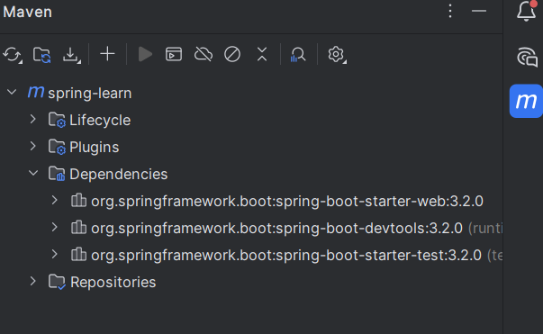

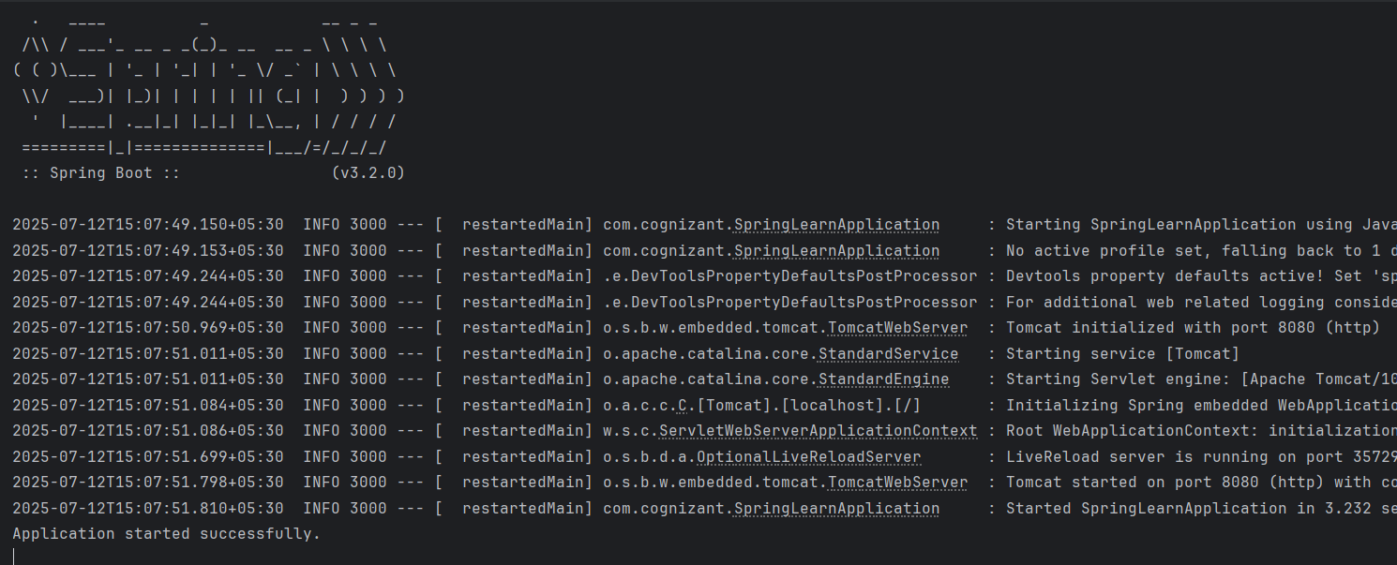

**HandsOn 2:** Spring Core – Load Country from Spring Configuration XML

**Code:**

**src/main/resources/country.xml** -

<?xml version="1.0" encoding="UTF-8"?>  
<beans xmlns="http://www.springframework.org/schema/beans"  
 xmlns:xsi="http://www.w3.org/2001/XMLSchema-instance"  
 xsi:schemaLocation="  
 http://www.springframework.org/schema/beans  
 http://www.springframework.org/schema/beans/spring-beans.xsd">  
  
 <bean id="country" class="com.cognizant.springlearn.Country">  
 <property name="code" value="IN" />  
 <property name="name" value="India" />  
 </bean>  
</beans>

**src/main/java/com/cognizant/springlearn/Country.java -**

package com.cognizant.springlearn;

import org.slf4j.Logger;

import org.slf4j.LoggerFactory;

public class Country {

private static final Logger LOGGER = LoggerFactory.getLogger(Country.class);

private String code;

private String name;

public Country() {

LOGGER.debug("Inside Country Constructor.");

}

public String getCode() {

LOGGER.debug("Getting code");

return code;

}

public void setCode(String code) {

LOGGER.debug("Setting code: {}", code);

this.code = code;

}

public String getName() {

LOGGER.debug("Getting name");

return name;

}

public void setName(String name) {

LOGGER.debug("Setting name: {}", name);

this.name = name;

}

@Override

public String toString() {

return "Country{" +

"code='" + code + '\'' +

", name='" + name + '\'' +

'}';

}

}

**src/main/java/com/cognizant/springlearn/SpringLearnApplication.java -**

package com.cognizant.springlearn;

import org.slf4j.Logger;

import org.slf4j.LoggerFactory;

import org.springframework.boot.autoconfigure.SpringBootApplication;

import org.springframework.boot.SpringApplication;

import org.springframework.context.ApplicationContext;

import org.springframework.context.support.ClassPathXmlApplicationContext;

@SpringBootApplication

public class SpringLearnApplication {

private static final Logger LOGGER = LoggerFactory.getLogger(SpringLearnApplication.class);

public static void main(String[] args) {

SpringApplication.run(SpringLearnApplication.class, args);

displayCountry();

}

public static void displayCountry() {

ApplicationContext context = new ClassPathXmlApplicationContext("country.xml");

Country country = context.getBean("country", Country.class);

LOGGER.debug("Country : {}", country.toString());

}

}

**src/main/resources/application.properties -**

logging.level.root=DEBUG

**pom.xml –**

<?xml version="1.0" encoding="UTF-8"?>  
<project xmlns="http://maven.apache.org/POM/4.0.0"  
 xmlns:xsi="http://www.w3.org/2001/XMLSchema-instance"  
 xsi:schemaLocation="http://maven.apache.org/POM/4.0.0 http://maven.apache.org/xsd/maven-4.0.0.xsd">  
 <modelVersion>4.0.0</modelVersion>  
 <groupId>com.cognizant</groupId>  
 <artifactId>spring-learn</artifactId>  
 <version>1.0-SNAPSHOT</version>  
 <parent>  
 <groupId>org.springframework.boot</groupId>  
 <artifactId>spring-boot-starter-parent</artifactId>  
 <version>3.2.0</version>  
 <relativePath/> <!-- lookup parent from repository -->  
 </parent>  
  
 <properties>  
 <maven.compiler.source>21</maven.compiler.source>  
 <maven.compiler.target>21</maven.compiler.target>  
 <project.build.sourceEncoding>UTF-8</project.build.sourceEncoding>  
 </properties>  
  
 <dependencies>  
 <dependency>  
 <groupId>org.springframework.boot</groupId>  
 <artifactId>spring-boot-starter-web</artifactId>  
 </dependency>  
 <dependency>  
 <groupId>org.springframework.boot</groupId>  
 <artifactId>spring-boot-devtools</artifactId>  
 <scope>runtime</scope>  
 </dependency>  
 <dependency>  
 <groupId>org.springframework.boot</groupId>  
 <artifactId>spring-boot-starter-test</artifactId>  
 <scope>test</scope>  
 </dependency>  
 <dependency>  
 <groupId>org.springframework.boot</groupId>  
 <artifactId>spring-boot-starter-logging</artifactId>  
 </dependency>  
</dependencies>

<build>  
 <plugins>  
 <plugin>  
 <groupId>org.springframework.boot</groupId>  
 <artifactId>spring-boot-maven-plugin</artifactId>  
 </plugin>  
 </plugins>  
 </build>  
</project>

**Output:**

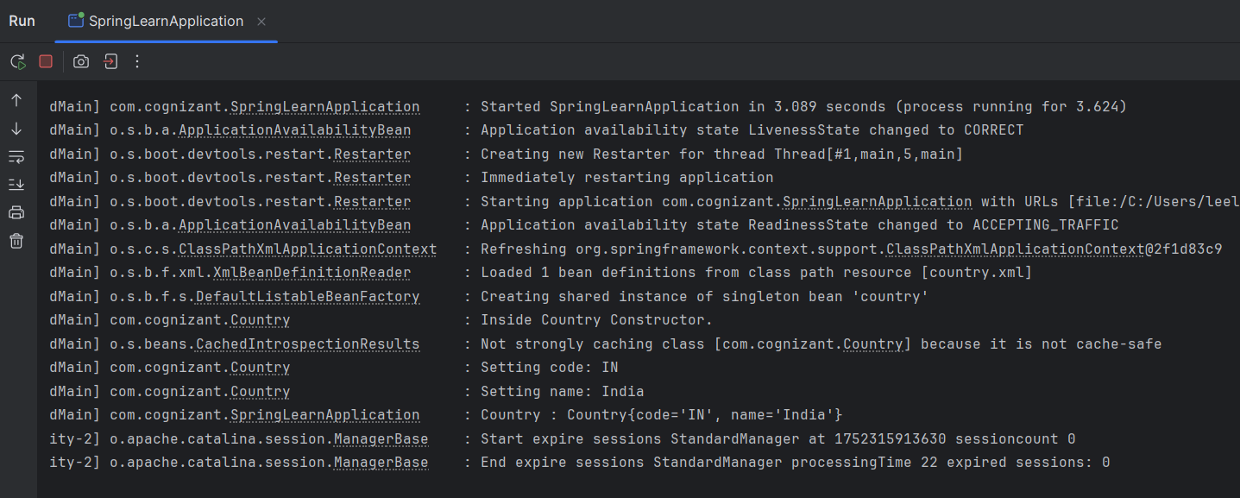

**HandsOn 3 -** Hello World RESTful Web Service

**Code:**

**src/main/resources/application.properties -**

server.port=8083

**src/main/java/com/cognizant/springlearn/controller/HelloController.java -**

package com.cognizant.springlearn.controller;

import org.slf4j.Logger;

import org.slf4j.LoggerFactory;

import org.springframework.web.bind.annotation.GetMapping;

import org.springframework.web.bind.annotation.RestController;

@RestController

public class HelloController {

private static final Logger LOGGER = LoggerFactory.getLogger(HelloController.class);

@GetMapping("/hello")

public String sayHello() {

LOGGER.info("START - sayHello()");

String message = "Hello World!!";

LOGGER.info("END - sayHello()");

return message;

}

}

**src/main/java/com/cognizant/springlearn/SpringLearnApplication.java -**

package com.cognizant.springlearn;

import org.springframework.boot.SpringApplication;

import org.springframework.boot.autoconfigure.SpringBootApplication;

@SpringBootApplication

public class SpringLearnApplication {

public static void main(String[] args) {

SpringApplication.run(SpringLearnApplication.class, args);

}

}

**Output (Tested in Postman) -**

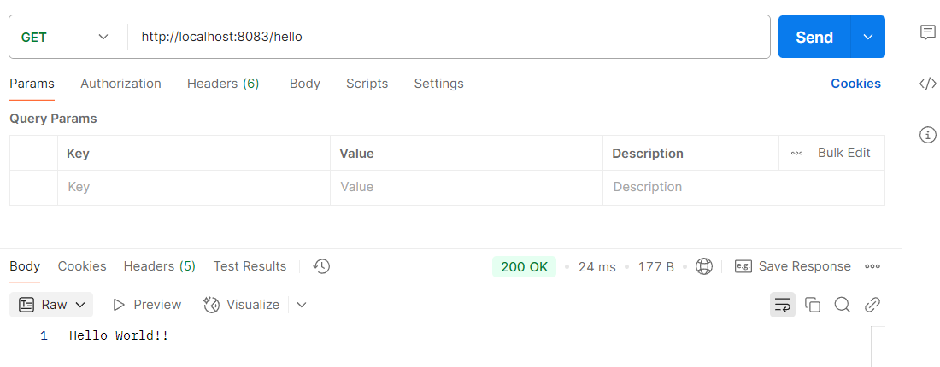

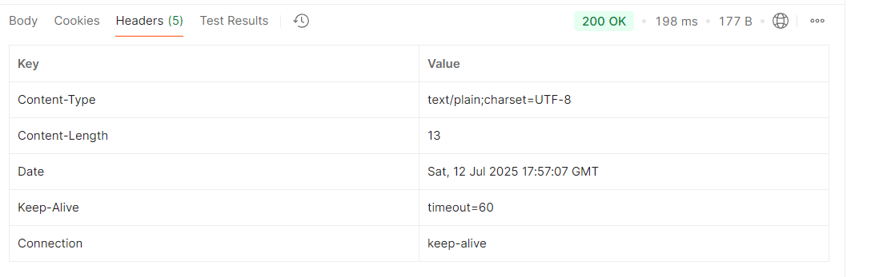

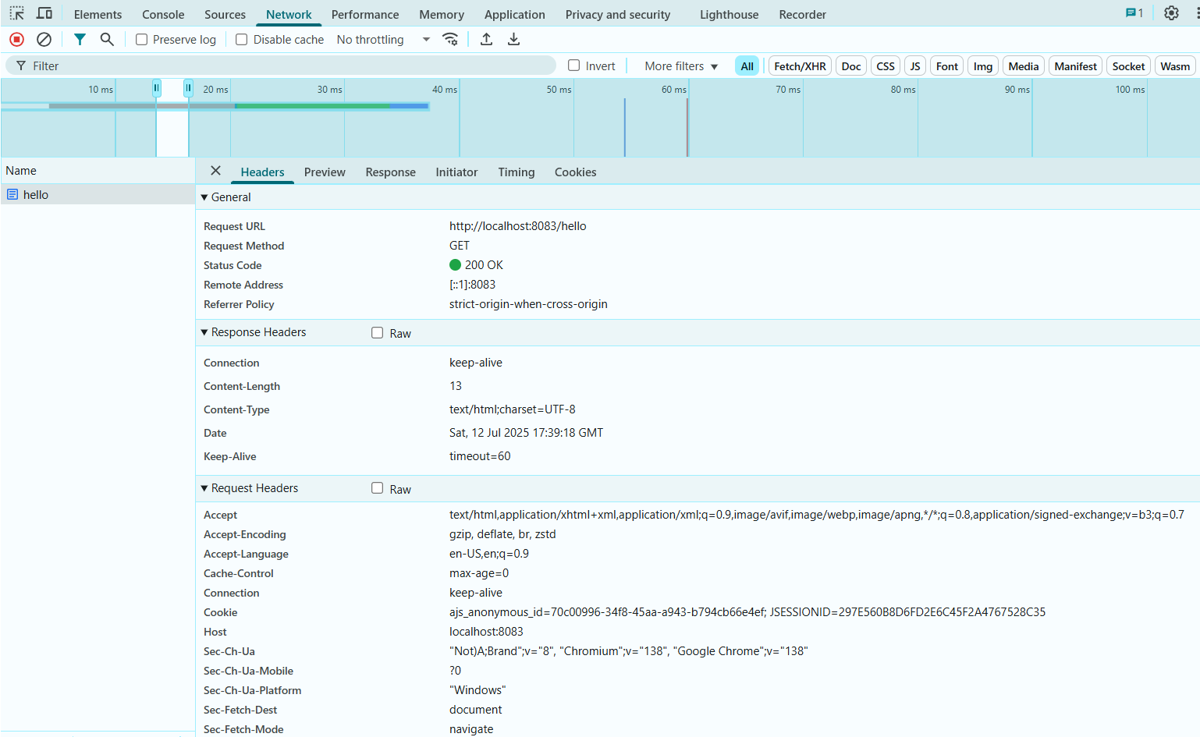

**HandsOn 4 -** REST - Country Web Service

**Code:**

**src/main/resources/application.properties -**

server.port=8083

**src/main/resources/country.xml -**

<?xml version="1.0" encoding="UTF-8"?>

<beans xmlns="http://www.springframework.org/schema/beans"

xmlns:xsi="http://www.w3.org/2001/XMLSchema-instance"

xsi:schemaLocation="

http://www.springframework.org/schema/beans

http://www.springframework.org/schema/beans/spring-beans.xsd">

<bean id="country" class="com.cognizant.springlearn.Country">

<property name="code" value="IN" />

<property name="name" value="India" />

</bean>

</beans>

**src/main/java/com/cognizant/springlearn/Country.java-**

package com.cognizant.springlearn;

public class Country {

private String code;

private String name;

public Country() {}

public String getCode() {

return code;

}

public void setCode(String code) {

this.code = code;

}

public String getName() {

return name;

}

public void setName(String name) {

this.name = name;

}

}

**src/main/java/com/cognizant/springlearn/controller/CountryController.java -**

package com.cognizant.springlearn.controller;

import com.cognizant.springlearn.Country;

import org.slf4j.Logger;

import org.slf4j.LoggerFactory;

import org.springframework.context.ApplicationContext;

import org.springframework.context.support.ClassPathXmlApplicationContext;

import org.springframework.web.bind.annotation.RequestMapping;

import org.springframework.web.bind.annotation.RestController;

@RestController

public class CountryController {

private static final Logger LOGGER = LoggerFactory.getLogger(CountryController.class);

@RequestMapping("/country")

public Country getCountryIndia() {

LOGGER.info("START - getCountryIndia()");

ApplicationContext context = new ClassPathXmlApplicationContext("country.xml");

Country country = context.getBean("country", Country.class);

LOGGER.info("END - getCountryIndia()");

return country;

}

}

**src/main/java/com/cognizant/springlearn/SpringLearnApplication.java -**

package com.cognizant.springlearn;

import org.springframework.boot.SpringApplication;

import org.springframework.boot.autoconfigure.SpringBootApplication;

@SpringBootApplication

public class SpringLearnApplication {

public static void main(String[] args) {

SpringApplication.run(SpringLearnApplication.class, args);

}

}

**Output:**

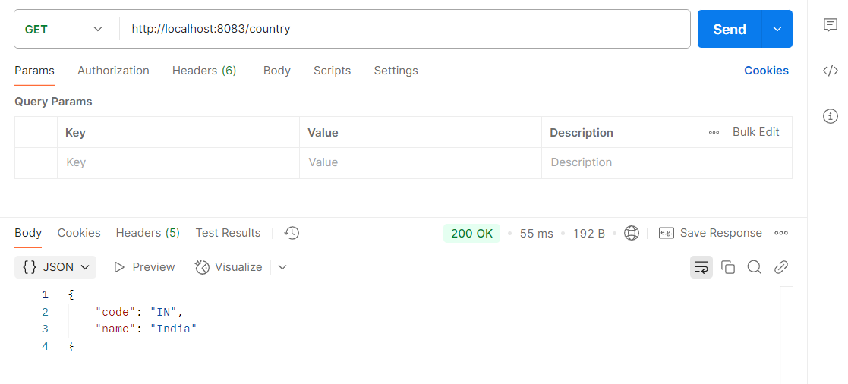

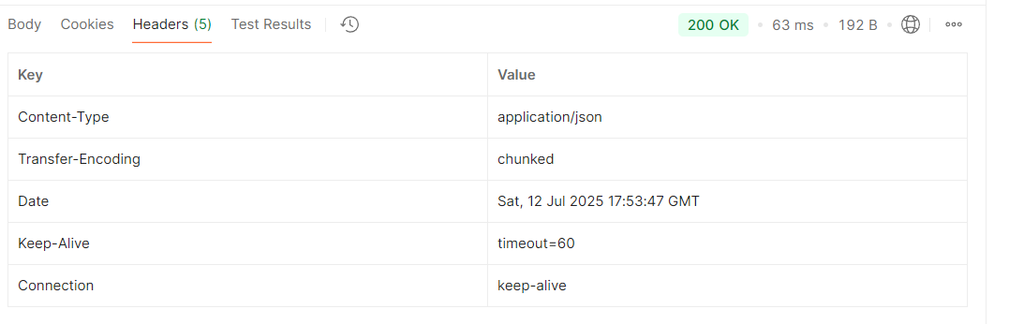

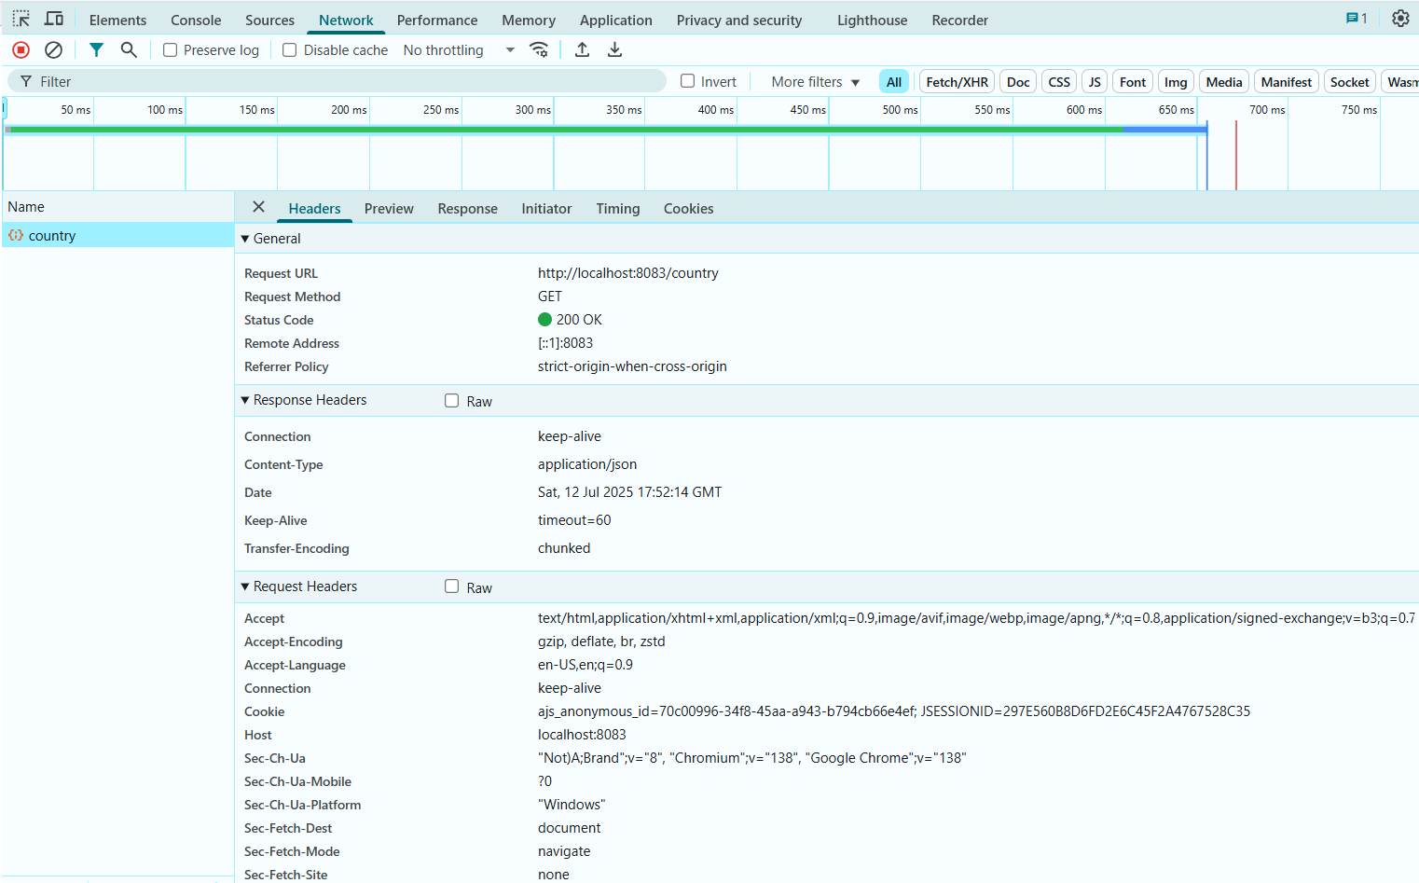

**HandsOn 5 -** REST - Get country based on country code

**Code:**

**src/main/resources/application.properties -**

server.port=8083

**src/main/resources/country.xml -**

<?xml version="1.0" encoding="UTF-8"?>

<beans xmlns="http://www.springframework.org/schema/beans"

xmlns:xsi="http://www.w3.org/2001/XMLSchema-instance"

xsi:schemaLocation="

http://www.springframework.org/schema/beans

http://www.springframework.org/schema/beans/spring-beans.xsd">

<bean id="countryList" class="java.util.ArrayList">

<constructor-arg>

<list>

<bean class="com.cognizant.springlearn.Country">

<property name="code" value="IN" />

<property name="name" value="India" />

</bean>

<bean class="com.cognizant.springlearn.Country">

<property name="code" value="US" />

<property name="name" value="United States" />

</bean>

<bean class="com.cognizant.springlearn.Country">

<property name="code" value="DE" />

<property name="name" value="Germany" />

</bean>

<bean class="com.cognizant.springlearn.Country">

<property name="code" value="JP" />

<property name="name" value="Japan" />

</bean>

</list>

</constructor-arg>

</bean>

</beans>

**src/main/java/com/cognizant/springlearn/Country.java-**

package com.cognizant.springlearn;

public class Country {

private String code;

private String name;

public Country() {}

public String getCode() {

return code;

}

public void setCode(String code) {

this.code = code;

}

public String getName() {

return name;

}

public void setName(String name) {

this.name = name;

}

}

**src/main/java/com/cognizant/springlearn/service/CountryService.java -**

package com.cognizant.springlearn.service;

import com.cognizant.springlearn.Country;

import org.springframework.context.ApplicationContext;

import org.springframework.context.support.ClassPathXmlApplicationContext;

import org.springframework.stereotype.Service;

import java.util.List;

@Service

public class CountryService {

public Country getCountry(String code) {

ApplicationContext context = new ClassPathXmlApplicationContext("country.xml");

List<Country> countryList = context.getBean("countryList", List.class);

return countryList.stream()

.filter(country -> country.getCode().equalsIgnoreCase(code))

.findFirst()

.orElse(null);

}

}

**src/main/java/com/cognizant/springlearn/controller/CountryController.java -**

package com.cognizant.springlearn.controller;

import com.cognizant.springlearn.Country;

import com.cognizant.springlearn.service.CountryService;

import org.springframework.beans.factory.annotation.Autowired;

import org.springframework.web.bind.annotation.*;

@RestController

public class CountryController {

@Autowired

private CountryService countryService;

@GetMapping("/country/{code}")

public Country getCountry(@PathVariable String code) {

return countryService.getCountry(code);

}

}

**src/main/java/com/cognizant/springlearn/SpringLearnApplication.java -**

package com.cognizant.springlearn;

import org.springframework.boot.SpringApplication;

import org.springframework.boot.autoconfigure.SpringBootApplication;

@SpringBootApplication

public class SpringLearnApplication {

public static void main(String[] args) {

SpringApplication.run(SpringLearnApplication.class, args);

}

}

**Output:**

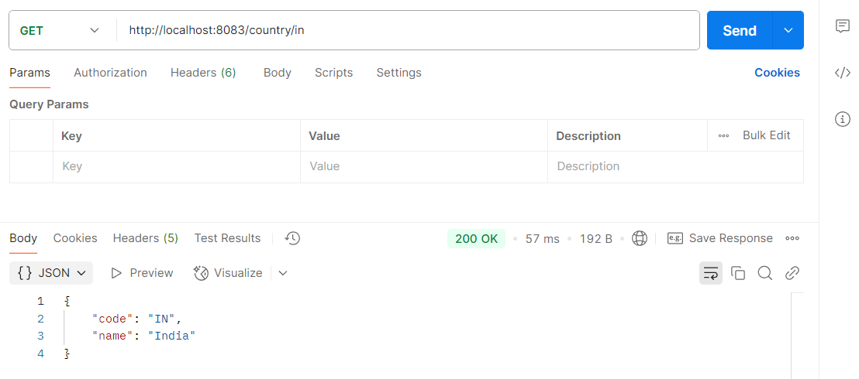

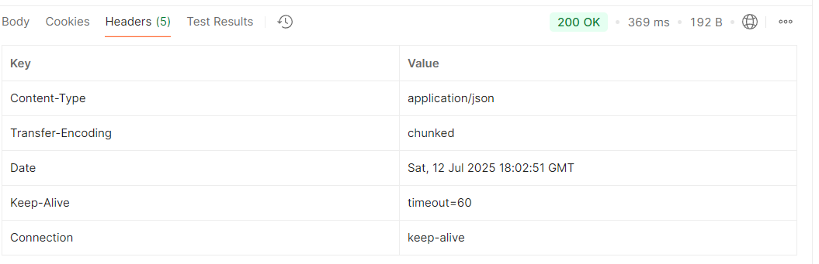

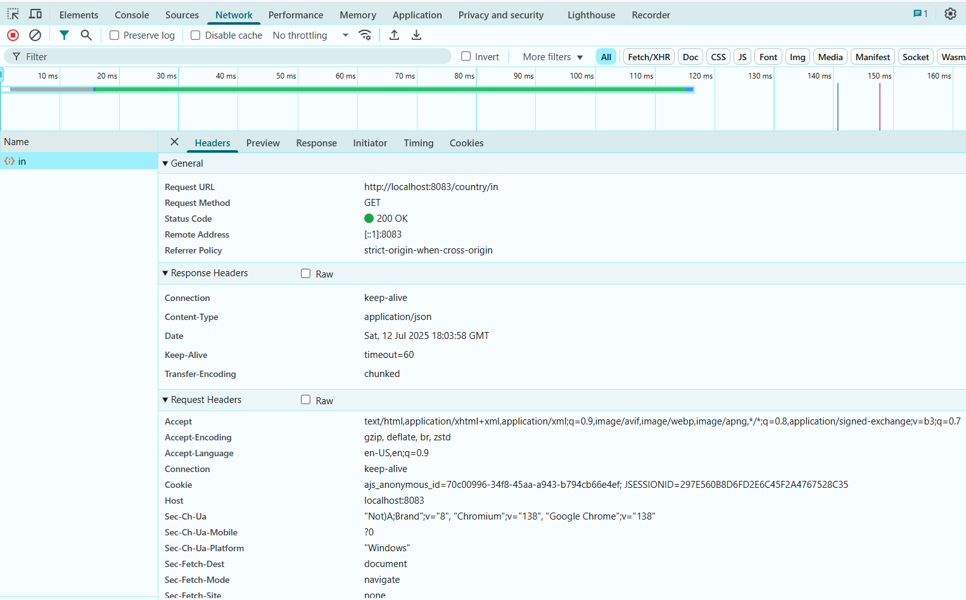

**HandsOn 6 -** Create authentication service that returns JWT

**Code:**

**src/main/java/com/cognizant/springlearn/controller/AuthenticationController.java –**

package com.cognizant.springlearn.controller;

import io.jsonwebtoken.JwtBuilder;

import io.jsonwebtoken.Jwts;

import io.jsonwebtoken.SignatureAlgorithm;

import org.slf4j.Logger;

import org.slf4j.LoggerFactory;

import org.springframework.web.bind.annotation.*;

import java.util.Base64;

import java.util.Date;

import java.util.HashMap;

import java.util.Map;

@RestController

public class AuthenticationController {

private static final Logger LOGGER = LoggerFactory.getLogger(AuthenticationController.class);

@GetMapping("/authenticate")

public Map<String, String> authenticate(@RequestHeader("Authorization") String authHeader) {

LOGGER.info("START - authenticate()");

LOGGER.debug("Authorization Header: {}", authHeader);

String user = getUser(authHeader);

String token = generateJwt(user);

Map<String, String> map = new HashMap<>();

map.put("token", token);

LOGGER.info("END - authenticate()");

return map;

}

private String getUser(String authHeader) {

LOGGER.debug("START - getUser()");

String encodedCredentials = authHeader.substring("Basic ".length());

byte[] decodedBytes = Base64.getDecoder().decode(encodedCredentials);

String decodedString = new String(decodedBytes);

String user = decodedString.split(":")[0];

LOGGER.debug("Decoded user: {}", user);

LOGGER.debug("END - getUser()");

return user;

}

private String generateJwt(String user) {

LOGGER.debug("START - generateJwt()");

JwtBuilder builder = Jwts.builder();

builder.setSubject(user);

builder.setIssuedAt(new Date());

builder.setExpiration(new Date((new Date()).getTime() + 20 * 60 * 1000)); // 20 mins

builder.signWith(SignatureAlgorithm.HS256, "secretkey");

String token = builder.compact();

LOGGER.debug("Generated token: {}", token);

LOGGER.debug("END - generateJwt()");

return token;

}

}

**src/main/java/com/cognizant/springlearn/SecurityConfig.java -**

package com.cognizant.springlearn;  
import org.springframework.context.annotation.Bean;  
import org.springframework.context.annotation.Configuration;  
import org.springframework.security.config.Customizer;  
import org.springframework.security.config.annotation.web.builders.HttpSecurity;  
import org.springframework.security.web.SecurityFilterChain;  
@Configuration  
public class SecurityConfig {  
 @Bean  
 public SecurityFilterChain securityFilterChain(HttpSecurity http) throws Exception {  
 return http  
 .csrf(csrf -> csrf.disable()) // disables CSRF safely using lambda  
 .authorizeHttpRequests(auth -> auth  
 .requestMatchers("/countries").hasRole("USER")  
 .requestMatchers("/authenticate").hasAnyRole("USER", "ADMIN")  
 .anyRequest().authenticated()  
 )  
 .httpBasic(Customizer.*withDefaults*()) // replaces deprecated httpBasic()  
 .build();  
 }  
}

**src/main/java/com/cognizant/springlearn/SpringLearnApplication.java -**

package com.cognizant.springlearn;

import org.springframework.boot.SpringApplication;

import org.springframework.boot.autoconfigure.SpringBootApplication;

@SpringBootApplication

public class SpringLearnApplication {

public static void main(String[] args) {

SpringApplication.run(SpringLearnApplication.class, args);

}

}

**Dependencies in pom.xml -**

<dependencies>  
 <dependency>  
 <groupId>org.springframework.boot</groupId>  
 <artifactId>spring-boot-starter-web</artifactId>  
 </dependency>  
 <dependency>  
 <groupId>org.springframework.boot</groupId>  
 <artifactId>spring-boot-devtools</artifactId>  
 <scope>runtime</scope>  
 <optional>true</optional>  
 </dependency>  
 <dependency>  
 <groupId>org.springframework.boot</groupId>  
 <artifactId>spring-boot-starter-test</artifactId>  
 <scope>test</scope>  
 </dependency>  
 <dependency>  
 <groupId>io.jsonwebtoken</groupId>  
 <artifactId>jjwt</artifactId>  
 <version>0.9.0</version>  
 </dependency>  
 <dependency>  
 <groupId>org.springframework.boot</groupId>  
 <artifactId>spring-boot-starter-security</artifactId>  
 </dependency>  
 <!-- For Java 11+ -->  
 <dependency>  
 <groupId>javax.xml.bind</groupId>  
 <artifactId>jaxb-api</artifactId>  
 <version>2.3.1</version>  
 </dependency>  
</dependencies>

**application.properties -**

server.port=8090  
spring.security.user.name=user  
spring.security.user.password=pwd  
spring.security.user.roles=USER

**Output:**

**In Postman -**

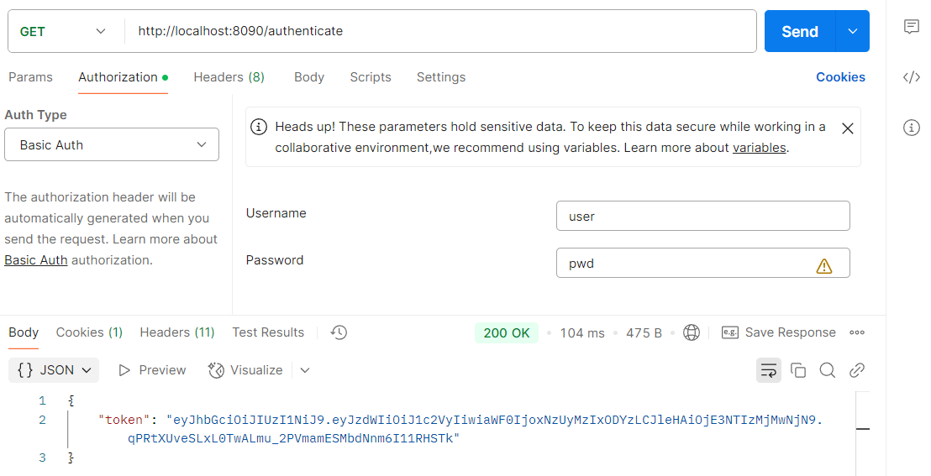

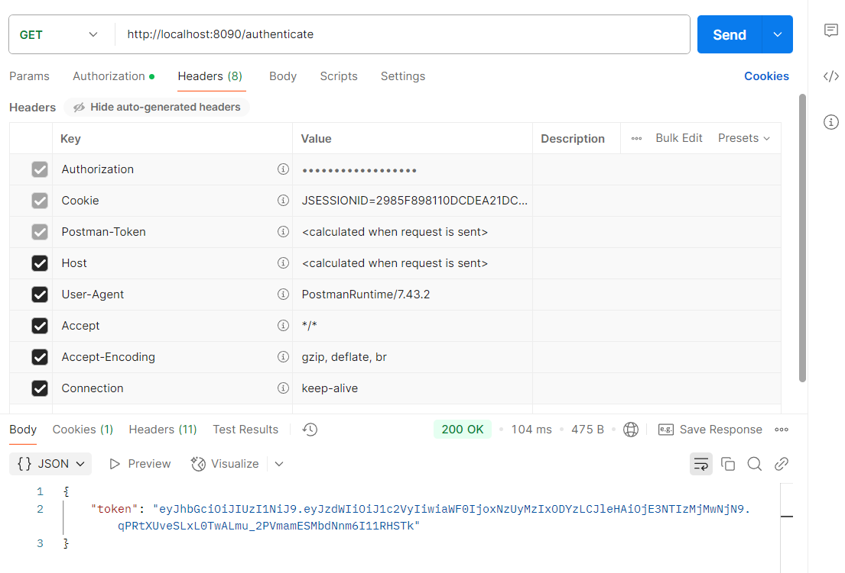

**In Browser -**

